Market Place

Group Members

1. Diksha Sharma 8765418
2. Avleen Kaur 8726146
3. Shivam Dahiya 8746999

PROG8750 and Capstone

Fourth

Submitted to

A.K Zaman

# **Market Place**

## **Introduction**

Our project is inspired by websites like Market Place from Facebook, eBay. The website will consist of two user profile. One is buyer and the other one is seller. From buyer profile the user will be able to order item listed by the seller user. User will be able to sign up using google account or make a new account using website.

## **Design and Data Flow**

The design and data flow of your project go here!

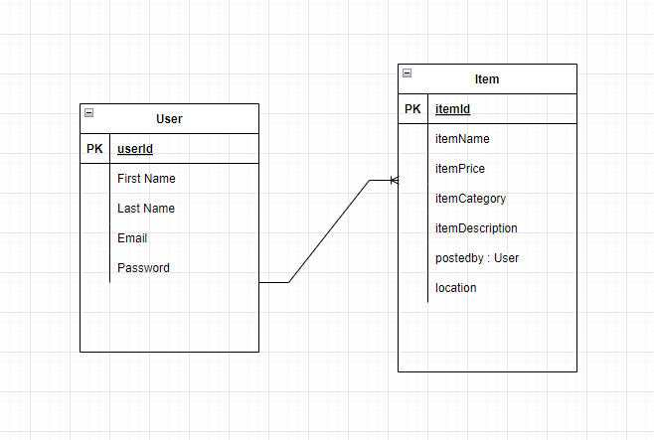

Take about design such as pages/windows, menu, database/ER Diagram, a block diagram for the data flow, etc.

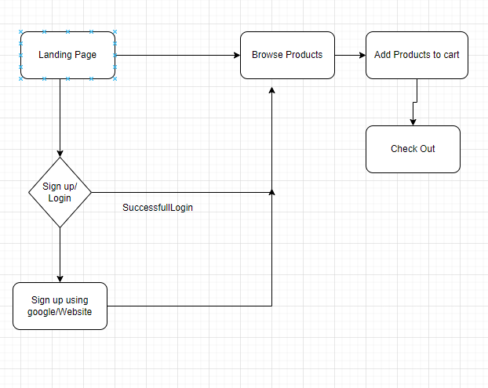

## **Technology Description:**

We will be using **MERN stack** for this project. MongoDB is one of the most famous online date base services which is free of charge and implement easily. For the Backend (server side) we will be using Node JS, and in NodeJS we will take help of express server. And for the design (Client Side) we will be using React, which is one of the most famous technologies in the industry.

## **Market Survey:**

Before coming up on the conclusion of using MERN stack for this project we have looked up the following technologies used by Market (Different Tech Industries.).

**For Front End:**

1. AngularJS
2. ReactJS
3. VueJS

**For Backend:**

1. Java Spring Boot
2. NodeJS
3. Php
4. .net
5. Django using Python

**For Database:**

1. MongoDB
2. Firebase
3. SQL

**For Version Control:**

1. GIT

## **Conclusion**

For this project we will stick to the given timeline and Sprints given in the instruction plan. We will be using SCRUM methodology to develop this project.

## **GitHub Link**

https://github.com/Dikshacm/cap_project_market_place